**BLIND MAN APPARATUS**

**Circuit diagram:**

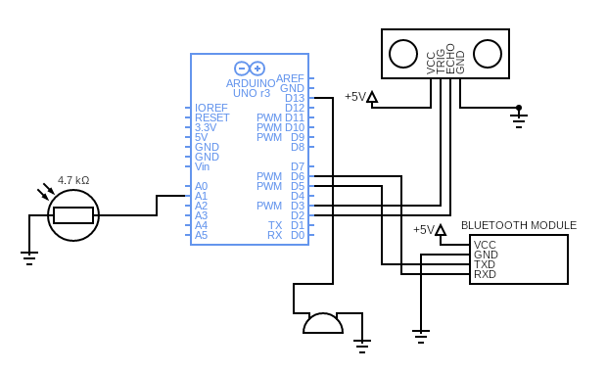

**Working of components**

**Arduino UNO Board:**

The user can get started by connecting the Uno to a computer with the USB cable or by powering it with an AC / DC adapter or battery. The Uno can be programmed with Arduino Software (Integrated Development Environment). Arduino Uno features 14 digital input / output pins (six of which can be used as PWM outputs), six analog inputs, and a 16MHz quartz crystal. Uno also includes a USB connection, a power jack, an In- Circuit Serial Programming (ICSP) header, and a reset button. This Arduino MCU board contains everything the user needs to support the MCU.

**Ultrasonic sensor:**

Ultrasonic sensors work by sending out a sound wave at a frequency above the range of human hearing. The transducer of the sensor acts as a microphone to receive and send the ultrasonic sound. Our ultrasonic sensors, like many others, use a single transducer to send a pulse and to receive the echo. The sensor determines the distance to a target by measuring time lapses between the sending and receiving of the ultrasonic pulse.

The working principle of this module is simple. It sends an ultrasonic pulse out at 40kHz which travels through the air and if there is an obstacle or object, it will bounce back to the sensor. By calculating the travel time and the speed of sound, the distance can be calculated. Ultrasonic sensors are a great solution for the detection of clear objects. For liquid level measurement, applications that use infrared sensors, for instance, struggle with this particular use case because of target translucence. For presence detection, ultrasonic sensors detect objects regardless of the color, surface, or material (unless the material is very soft like wool, as it would absorb sound.)

**LDR:**

The working principle of an LDR is photoconductivity, which is nothing but an optical phenomenon. When the light is absorbed by the material then the conductivity of the material enhances. When the light falls on the LDR, then the electrons in the valence band of the material are eager to the conduction band. But, the photons in the incident light must have energy superior to the bandgap of the material to make the electrons jump from one band to another band (valance to conduction).

Hence, when light having ample energy, more electrons are excited to the conduction band which grades in a large number of charge carriers. When the effect of this process and the flow of the current starts flowing more, the resistance of the device decreases.

**HC-05 Bluetooth Module:**

The Bluetooth standard, like WiFi, uses the FHSS technique (Frequency-Hopping Spread Spectrum), which involves splitting the frequency band of 2.402-2.480 GHz into 79 channels (called hops), each 1MHz wide. Then it transmits the signal using a sequence of channels known to both the sending and receiving stations. Thus, by switching channels as often as 1600 times a second, the Bluetooth standard can avoid interference with other radio signals.

The Bluetooth standard is based upon a master/slave operational mode. The term piconet is used to refer to the network formed by one device and all devices found within its range. Up to 10 piconets can coexist within a single coverage area. A master can simultaneously connect to up to 7 active slave devices (255 when in parked mode). Devices in a piconet have a logical address of 3 bits, for a maximum of 8 devices. Devices in parked mode are synchronized, but do not have their own physical address in the piconet.In reality, at a given moment, the master device can only be connected to a single slave at once. Therefore, it quickly switches between slaves in order to make it seem as if it is simultaneously connected to all the slave devices. Bluetooth enables two piconets to be linked to one another in order to form a wider network, called a scatternet, using certain devices which act as a bridge between the two piconets.

HC-05 Bluetooth Module is an easy-to-use Bluetooth SPP (Serial Port Protocol) module, designed for transparent wireless serial connection setup. Its communication is via serial communication which makes an easy way to interface with controller or PC.

**Buzzer:**

The buzzer is connected to the D3 pin of Arduino. It consists of an outside case with two pins to attach it to power and ground. Inside is a piezo element, which consists of a central ceramic disc surrounded by a metal (often bronze) vibration disc. When current is applied to the buzzer it causes the ceramic disk to contract or expand. Changing the This then causes the surrounding disc to vibrate. That’s the sound that you hear. By changing the frequency of the buzzer, the speed of the vibration’s changes, which changes the pitch of the resulting sound.